Impact of COVID-19 on Quality of Education with Visualization Techniques

Inshira Noor,Itrat Batool Naqvi,Shakila Bashir

[itratnaqvi@fccollege.edu.pk](mailto:itratnaqvi@fccollege.edu.pk)

[inshiranoor1@gmail.com](mailto:inshiranoor1@gmail.com)

**Abstract**

The COVID-19 pandemic had caused education to experience unprecedented disruptions, requiring a fast shift to remote learning and posing multiple challenges for students and educators everywhere. Using secondary data and data visualization approaches, this study seeks to render a thorough overview of the pandemic’s effects on educational quality. Leveraging secondary data, the study focuses on students in Delhi and the National Capital Region (NCR) of India and examines different facets of educational quality, including student experiences during the pandemic, access to technology, study time, and social media usage. Data on a variety of pandemic-related topics, including online class time, online class experience rating, medium for online classes, self-study time, fitness routines, sleep patterns, social media usage, and more, was gathered through a survey conducted among 1,182 individuals from various educational institutions. The study examines the connections and trends among these variables by utilizing data visualization techniques such as tree maps, bar graphs, scatter plots, and 3-D models. The findings showcase that the COVID-19 pandemic had significantly affected schooling, as seen by considerable changes in online class time, self-study hours, sleep patterns, exercise routines, and gadget usage. The time spent in online classes was notably inversely correlated with increased social media use during the pandemic, raising questions about potential academic disruptions. The results highlight the urgent necessity for all-encompassing measures and initiatives to lessen the pandemic’s negative effects on the standard of schooling. Policymakers, educators, and other stakeholders can use the knowledge collected from this study to develop focused efforts to improve educational quality, foster student wellbeing, and address issues related to distant learning.

**Keywords:** COVID-19, education quality, secondary data analysis, data visualization, student experiences, online classes, social media use.

**Introduction**

During the Covid-19 pandemic, the world has experienced some extremely dark and lonesome days. The catastrophic pandemic had profoundly impacted everyone’s emotional well-being in addition to the socioeconomic equilibrium of the entire world. Although it had been noted that the Novel Coronavirus (COVID-19) pandemic had initially begun in China, the World Health Organization only proclaimed it to be a pandemic in March 2020. More than 200 countries had been infected by the virus (Imran et al., 2020). The Covid-19 pandemic caused trepidation and apprehension in the minds of individuals since outbreaks of such fatal transmissible illnesses are known to wreak havoc among the populace. In order to flatten the curve and stop the spread of the disease, lockdown and homebound techniques had been implemented (Pokhrel, & Chhetri, 2021).

The recent outbreak of Corona Virus illness (COVID-19) had prompted a global public health emergency that is unprecedented in history. Emergency procedures were put in place in India to stop the virus’s spread, which led to constraints on all non-urgent public movements. Closures of educational institutions and lockdowns did not only have a short-term impact on the continuity of edification for the young learners in a country like India, where 42.1% of the populace is burdened by educational disparities (United Nations Development Program-UNDP, 2014), but also triggered extensive socio-economic consequences; around 600 million students were thought to be affected by the closure of educational institutions, including more than 285 million young students in India. (Bokde et al., 2020).

In consequence to the lethal pandemic a plethora of colleges, universities, and schools had stopped offering in-person instruction. Innovation and the utilization of new educational and assessment methods were immediately needed. The COVID-19 pandemic had given us the chance to set the stage for the introduction of digital learning. In regard to online learning, comprehension gap and the adverse environment for learning at home were only a few of the shortcomings that were perceived. Other imperfections consisted of the inadequate infrastructure for online teaching, the restricted exposure of teachers to online teaching, along with the lack of online teaching expertise.

Furthermore, the COVID-19 pandemic had resulted in an enormous spike in social media users, in India, as a result of the forced deployment of online pedagogy and travel limitations (Sengupta & Vaish, 2023). The COVID-19 pandemic has altered the worldwide social media environment, affecting people from all walks of life, including celebrities, international leaders, and professionals. While social media services were critical in distributing information and providing entertainment and distraction through internet memes during the pandemic, it placed immense pressure on one’s mental health (Lelisho et al., 2023). Consequently, it being detrimental on schooling. As students got more reliant on social media for communication and enjoyment, it became a source of distraction and decreased focus during their academics. The constant barrage of notifications, along with the attractiveness of social media content, posed challenges to maintaining productivity and academic achievement.

The objective of this research paper is to examine the effects of the COVID-19 pandemic on the quality of education utilizing secondary data and visualizing the data via R. By leveraging secondary data, this study aims to gain insights into the impact of the pandemic on various aspects of education quality, including access to technology, hours spent on social media platforms, the time utilized to study, etc.

**Methodology**

In this study, secondary data was utilized to investigate how COVID-19 had affected students in Delhi and the National Capital Region (NCR) of India. The manner for acquiring the data included surveying a total of 1,182 individuals from different educational institutions in the area. The survey, comprising of 18 questions/categories, aimed to gather data on a number of significant pandemic-related issues, including region of residence, age of subject, time spent on online class, rating of online class experience, medium for online class, time spent on self-study, time spent on fitness, time spent in sleep, time spent on social media, preferred social media platform, time spent on T.V, number of meals per day, changes in weight, health issues during lockdown, stress busters, time utilized, connectivity with family and what did individuals miss the most (Chaturvedi, Vishwakarma & Singh, 2021).

This study employed R, a statistical programming language and environment, to analyze secondary data and impart a range of visualizations to improve comprehension of COVID-19’s effects on educational quality. To investigate the connections, patterns, and trends found in the data, a variety of visualization approaches were adopted: tree maps, histograms, scatter plot matrix, correlation matrix, logistics, 3D model, etc.

|  |  |
| --- | --- |
| Figure 1a: Tree map for Medium Utilized During COVID-19 for Online Classes | A graph of a number of devices  Description automatically generated with medium confidence  Figure 1b: Bar Chart for Medium Utilized During COVID-19 for Online Classes |

From Figure 1a: According to the assessment of the presented tree map, the majority of individuals are mostly adopting laptop/desktop computers as their preferred medium for online classes during the COVID-19 pandemic. This is seen from the tree map’s extensive representation of laptops and desktops relative to other devices.

Smartphones are the next most often used device for online classes after laptops/desktops, evidenced by the enormous portion of the tree map devoted to this category. Given their widespread usage and portability, smartphones offer a practical and affordable option for people to enroll in online programs.

The remaining categories, such as tablets and other gadgets, seem to have much smaller representations in the tree map, on the other hand. This implies that just a small percentage of those surveyed adopt tablets or other technology as their primary means for attending online classes during the pandemic.

The tree map image successfully conveys how laptops, desktop computers, and smartphones predominate in aiding online learning. The stark size difference between these two groups and the others emphasizes how popular and preferred these devices are among the individuals who were questioned.

From figure 1b: The x-axis of the bar chart showcases the distribution of online class mediums, while the y-axis shows the number of occurrences for each medium. According to the statistics, 550 people reported taking online classes using laptops, which is the largest percentage of the sample as a whole. With a count of 539, smartphones were the second-most popular media. 5 people reported using gadgets, while 37 respondents reported using tablets.

The bar chart makes it possible to compare the frequency of various online learning mediums visually. It clearly demonstrates the dominance of computers and smartphones as the preferred mediums, with relatively fewer people using gadgets and tablets. This data reveals that among the respondents to the study, computers and smartphones are more frequently available or preferred for taking online classes.

|  |  |
| --- | --- |
| A diagram of a tree map  Description automatically generated  Figure 2a: Tree map for Rating Online Class Experience | A graph of a bar chart  Description automatically generated with medium confidence  Figure 2b: Bar Chart for Rating Online Class Experience |

From Figure 2a: The greatest area of the tree map corresponds to the category “very poor”, showing that a significant number of individuals had a very negative opinion of their experience of taking online classes. The region reflecting the “average” assessment is considerably smaller after the category of “very poor”, showing that a smaller percentage thought their online class experience was somewhat satisfying. The “good” rating category is represented by a smaller area than “average”, which demonstrates that a smaller number of individuals gave their online class experience a favorable review. The “excellent” rating category is likewise highlighted in a smaller area on the tree map, indicating that a lower proportion of respondents had a very favorable opinion of online courses. Last but not least, the category “poor” has a smaller area, indicating that fewer individuals thought their experience was below average. Overall, the tree map shows how the opinions of individuals on distance learning are distributed visually. The majority of respondents expressed displeasure or thought their experience was extremely poor, demonstrating a predominance of unfavorable sentiment among the respondents. The map also illustrates that students’ opinions of online courses were generally less favorable. This interpretation offers a quick look at how people feel about taking online classes, giving insights into general levels of satisfaction.

From figure 2b: The ratings for online courses taken during the COVID-19 period can be seen in the bar chart. With each rating category shown on the x-axis and the matching percentage of respondents on the y-axis, it offers insights into the distribution of ratings provided by respondents. The majority of respondents, or 53.7%, gave the online classes a “very poor” rating, as seen in the chart. This suggests that there is a serious level of discontent or problems with the experience and quality of the classes. It implies that during the COVID-19 era, a sizable proportion of respondents had an unfavorable opinion of the online learning environment. Nevertheless, 33.4% of the respondents supplied a “average” grade, signifying a mediocre or only somewhat satisfied quality of their experience. Inferring a neutral or mixed assessment, this shows that a sizable portion of respondents did not think the online classes were particularly beneficial or detrimental. 19.9% of respondents gave the online classes a respectable rating of “good” .This suggests that they enjoyed their overall experience and thought the classes were of a high enough caliber. Furthermore, 8.5% of the respondents gave an “excellent” grade, signifying a highly favorable experience and top-notch online courses. Finally, the “poor” rating category obtained the lowest proportion, 2.6%, indicating that very few respondents throughout the COVID-19 period had a bad experience with the online classes. The overall perceptions and experiences people had with online education during the COVID-19 period are shown in the bar chart. It draws attention to the respondents’ general unhappiness, a range of perspectives, and supportive comments while also offering insightful information about how they view the online learning environment.

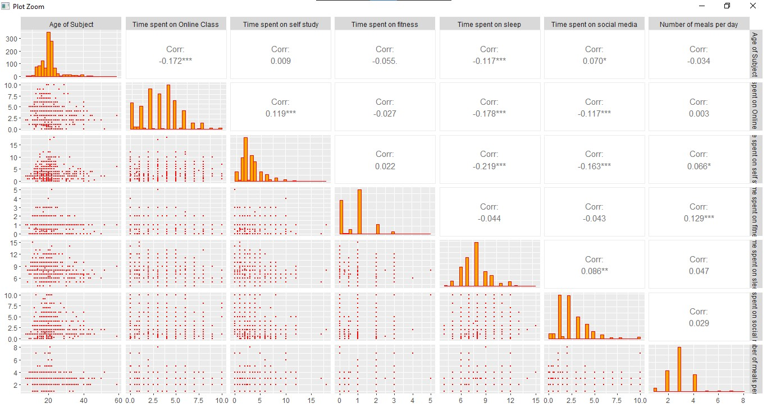In comparison to a typical bar chart, a tree map is a visualization technique that has several advantages. Tree maps are excellent at showing the relative sizes and proportions of various categories or groupings within the data. Each rectangle’s area in the tree map is proportional to the size or percentage of the category it represents. This visual encoding can be especially useful when comparing the sizes of various categories or when emphasizing the categories that are most prevalent in the data.

Figure 3. Correlation Matrix/Histogram/Scatter Matrix

A scatter plot matrix, often called a scatterplot matrix or a pairwise scatter plot, is a diagram that shows the connections between many variables. It is made up of a grid of scatter plots, each of which contrasts two dataset variables. A scatter plot uses dots to symbolize each data point, and the values of the variables under comparison determine where the dot is located on the graph. You may see how the variables interact with one another and spot potential patterns or correlations by looking at the scatter plots in the matrix. When working with multivariate data, where there are multiple variables that could potentially influence one another, a scatter plot matrix is especially beneficial. It permits you to analyze the connections between variables in pairs and get understanding of the overall data structure.

A statistical concept called correlation assesses the direction and degree of a relationship between two variables. It offers insightful information about how variations in one variable impact variations in another. The correlation coefficient, commonly represented by the letter “r”, is between -1 and +1. If the variables are positively correlated, they are moving in the same direction, which means that if one variable rises, the others likewise tend to rise. A negative correlation, on the other hand, denotes an inverse relationship, whereby when one measure rises, the other tends to fall.

The correlations found in the provided data may have consequences in light of the COVID-19 pandemic. Age and time spent exercising have a weak negative connection (-0.055), which may indicate that older people will spend less time exercising during the pandemic. This might be the result of things like rising health concerns, restricted access to fitness centers, or a change in priorities in favor of other facets of health and wellbeing. The weak negative correlation (-0.044) between time spent exercising and time spent sleeping suggests that people who exercise more may not necessarily sleep less. This implies that they may be able to efficiently organize their schedules to allow for both exercise and enough sleep, which is essential for general health and immunity, especially during a pandemic.

The slight positive association between the amount of time spent exercising and the number of meals consumed each day (0.129) suggests that people who place a high priority on exercising may also pay attention to their nutritional intake by eating more meals. This connection may result from the knowledge that healthy eating promotes physical performance and recuperation, which is necessary at a time when maintaining good health is essential. The weak negative connection (-0.219) between the amount of time spent sleeping and the amount of time spent studying shows that people who spend more time studying might get somewhat less sleep overall. This might be related to heightened stress levels during the pandemic, higher academic obligations, or changes to distant learning.

Graphs called histograms serve to illustrate how a dataset’s distribution looks. They display the frequency or number of observations that fall into various “bins”, or intervals, along a continuous variable. A histogram’s x-axis displays the variable being measured, broken down into intervals or bins. The frequency or count of observations falling within each bin is shown on the y-axis. It can be perceived that each respective histogram of every aforementioned variable in the above given figure in skewed towards the right. A histogram that is skewed to the right suggests that higher values tend to appear less frequently than lower values do. The left side of the histogram is where the most frequent or average values are found, and this is where the peak or highest point of the histogram is placed. The frequency or count of occurrences gradually declines as the values rise.

This skew-ness pattern can be seen in several of the analyzed variables. This right-skewed distribution, for instance, may be seen in the amount of time spent taking online courses, studying alone, exercising, and sleeping. It suggests that while fewer respondents indicated greater values or more time spent, the majority of respondents may have reported lower values or less time spent on these activities. Several variables may have an impact on how skewed these variables are. For instance, access to resources, technology, or designated study places may have been restricted or difficult during the COVID-19 pandemic, reducing the amount of time spent on online learning and independent study. Like how usual routines may have been disrupted, stress levels may have increased during the pandemic, affecting physical activities and sleep patterns.

Figure 4. How Did the Sampled Respondents Utilize Their Time

The associations between three numerical variables are shown in a three-dimensional scatter plot utilizing a style of data visualization called a 3-D scatter plot. It is a development of the conventional scatter plot. Each data point in a 3-D scatter plot is represented by a marker that is placed in space according to the values of the three variables.

In a 3-D scatter plot, the three axes stand in for the three variables being examined. Each data point’s position is decided by its corresponding values for the three variables. For instance, if we have variables x, y, and z, the x-axis represents values for variable x, the y-axis represents values for variable y, and the z-axis represents values for variable z. The time spent on social media and the time allotted for online classes and self-study during the COVID-19 pandemic are perceived to have a negative association in the 3-D scatter plot. According to this inverse relationship, less time is spent studying and taking online courses as social media use grows.

This trend may have been caused, in part, by how the COVID-19 pandemic affected individuals’ patterns of behavior on a regular schedule. There may have been a greater temptation or diversion to spend more time on social media platforms as a result of the transition to remote learning and increased reliance on digital platforms. Individuals may have sought out more frequent social media participation as a method of diversion, relaxation, or remaining in touch with friends and family because to the uncertainty and worry brought on by the pandemic.

Furthermore, an imbalance in time management may have resulted from the pandemic’s overwhelming accessibility and availability of social media platforms. It may be difficult for individuals to keep a strict schedule and put self-study and online classes ahead of social media’s allure. Learners may be distracted from their academic obligations by the continual notifications, entertainment, and social connections offered by social media sites.

**Discussion**

In conclusion, the aforementioned research conducted sheds insight on the COVID-19 pandemic’s effects on educational quality and the numerous elements that affect it. We were able to acquire insights into the patterns and correlations among various variables by leveraging secondary data which focuses on students in Delhi and the National Capital Region (NCR) of India, and applying data visualization techniques such as tree maps, bar plots, scatter plots, and 3D models using R. The outcomes demonstrate that the COVID-19 pandemic has significantly affected education, as evidenced by changes in online class time, independent study time, sleep patterns, exercise routines, and gadget use. Different social media platforms were utilized by students to partake in online classes, with laptops and desktops being the most popular that being 48.63% from Figure 1a and 1b, followed by smartphones with 47.66% from Figure 1a and 1b and tablets with 3.27% from Figure 1a and 1b. Furthermore, it was revealed that growing social media activity during the pandemic was inversely related with the amount of time spent in online classes which comply with their correlation value -0.117 from Figure 3. In a nut-shell all such factors contribute towards raising the possibility of an academic distraction.

The investigation also showed relationships between several factors, including time spent exercising and sleeping, and the general well-being and health problems encountered during the pandemic. However, further research and analysis of confounding variables are necessary given the precise nature as well as size of these correlations. Overall, this study emphasizes the necessity of all-encompassing measures and treatments to lessen the COVID-19 pandemic’s detrimental consequences on schooling. These results can help policymakers, educators, and other stakeholders design focused strategies to improve educational quality, boost student wellbeing, and overcome challenges associated with distance learning.

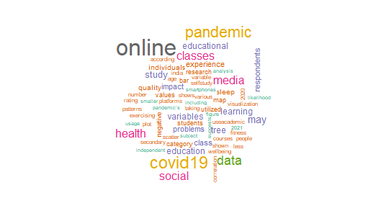Lastly, to emphasize the most frequently used words, observed in this paper, connected with the influence of the COVID-19 pandemic on educational quality are highlighted in the word cloud created from the analysis of the research findings. The words “pandemic”, “online” and “COVID-19” stand out in the word cloud’s center, highlighting the study’s main focus. We notice key words like “social”, “classes”, “health” and “media” surrounding these crucial themes. These terms capture the linked elements of the pandemic’s impact on education, such as the shift to online learning, the social effects on students’ wellbeing, and the function of media in supporting distance learning. The key topics of the study are shown in this word cloud, which also highlights the key themes that arose from the data analysis. It offers a graphically appealing summary, highlighting the significance of these terms in comprehending the pandemic’s consequences on educational quality.

Figure 5. Word Cloud of COVID-19 of Said Paper

**Recommendations**

There are various suggested techniques for future research to further examine the effect of COVID-19 on the standard of education. In-depth understanding of the experiences and viewpoints of students, instructors, and parents can be gained through qualitative interviews. Case studies that concentrate on particular institutions or locations might provide insightful advice and suggest best practices. Studies that follow subjects over time can monitor changes and long-term impacts. Comparative research between various locations or nations can reveal differences and help decision-makers use evidence. Research using mixed methods, which combines qualitative and quantitative methodologies, can offer a thorough insight. The effectiveness of interventions can be assessed through experimental research and randomized controlled trials. These research techniques will enhance our comprehension and advance the use of practices and policies in education that are supported by solid data.

References

Bokde, V., Kharbikar, H. L., Roy, M. L., Joshi, P., & Ga, A. (2020). Possible impacts of

COVID-19 pandemic and lockdown on education sector in India. *Food and Scientific*

*Reports*, *1*(Special Issue), 30-33.

Chaturvedi, K., Vishwakarma, D. K., & Singh, N. (2021). COVID-19 and its impact on

education, social life and mental health of students: A survey. Children and youth

services review, 121, 105866.

Imran, N., Zeshan, M., & Pervaiz, Z. (2020). Mental health considerations for children &

adolescents in COVID-19 Pandemic. *Pakistan journal of medical sciences*, *36*(COVID19-S4), S67.

Pokhrel, S., & Chhetri, R. (2021). A literature review on impact of COVID-19 pandemic on

teaching and learning. *Higher education for the future*, *8*(1), 133-141.

Lelisho, M. E., Pandey, D., Alemu, B. D., Pandey, B. K., & Tareke, S. A. (2023). The negative

impact of social media during COVID-19 pandemic. *Trends in Psychology*, *31*(1), 123-

142.

Sengupta, S., & Vaish, A. (2023). A study on social media and higher education during the COVID-19 pandemic. *Universal Access in the Information Society*, 1-23.